Whenever you get this type of error in any page , it is because PHP Version I have developed this application in older version of php , so don’t worry about that just put the line

error_reporting(0); at the beginning of PHP line Code

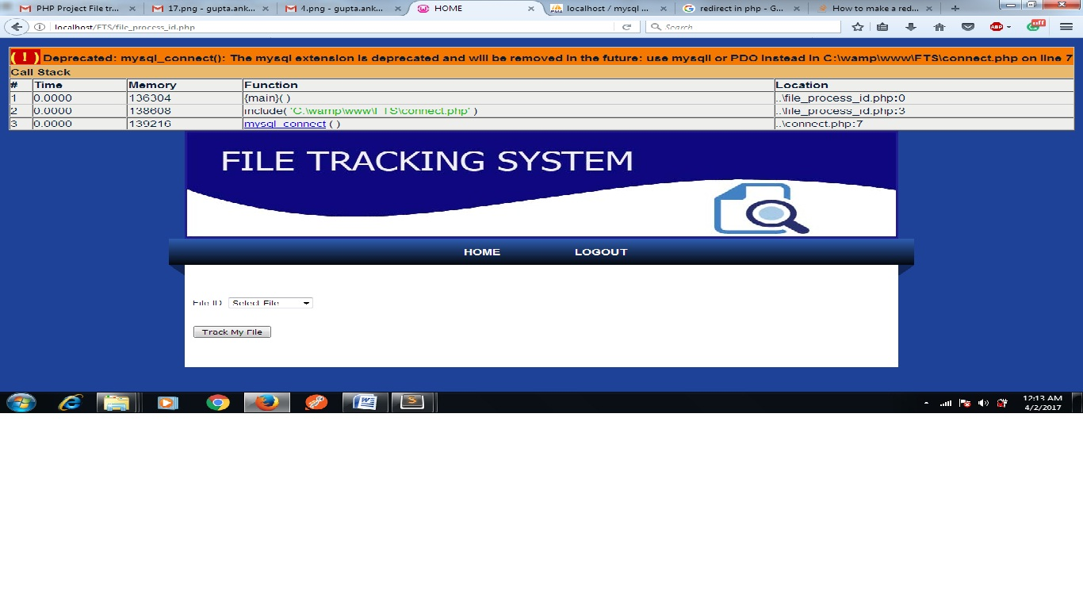

ERROR CORRECT SCREEN SHOT:-

